Q.1.

By using binary search, we do not go through each element we will just use the half we need.

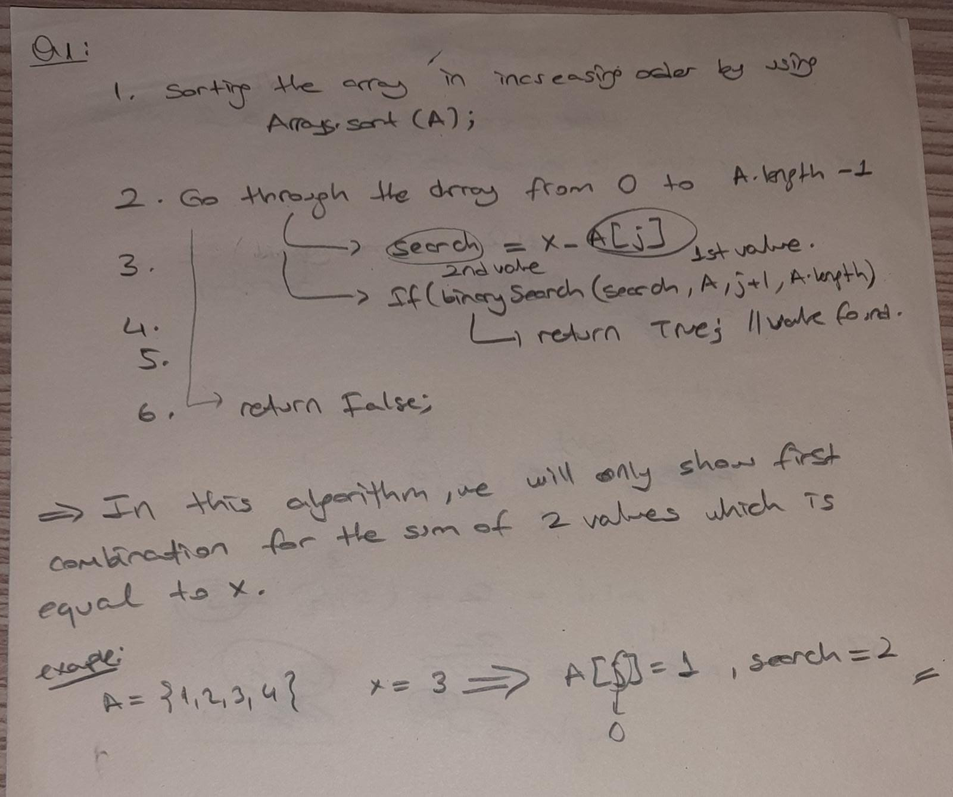

Q.2.

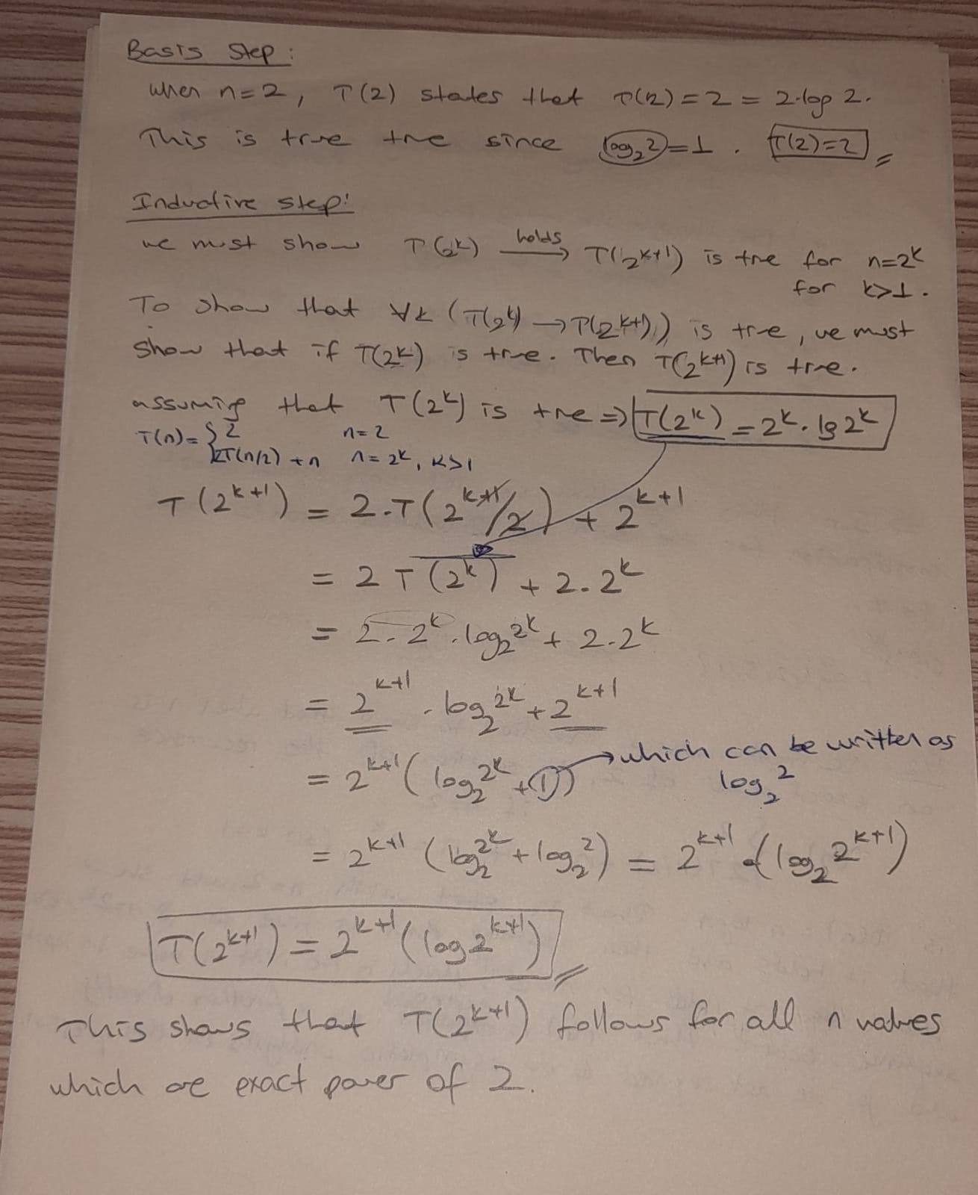

Q.3.a.

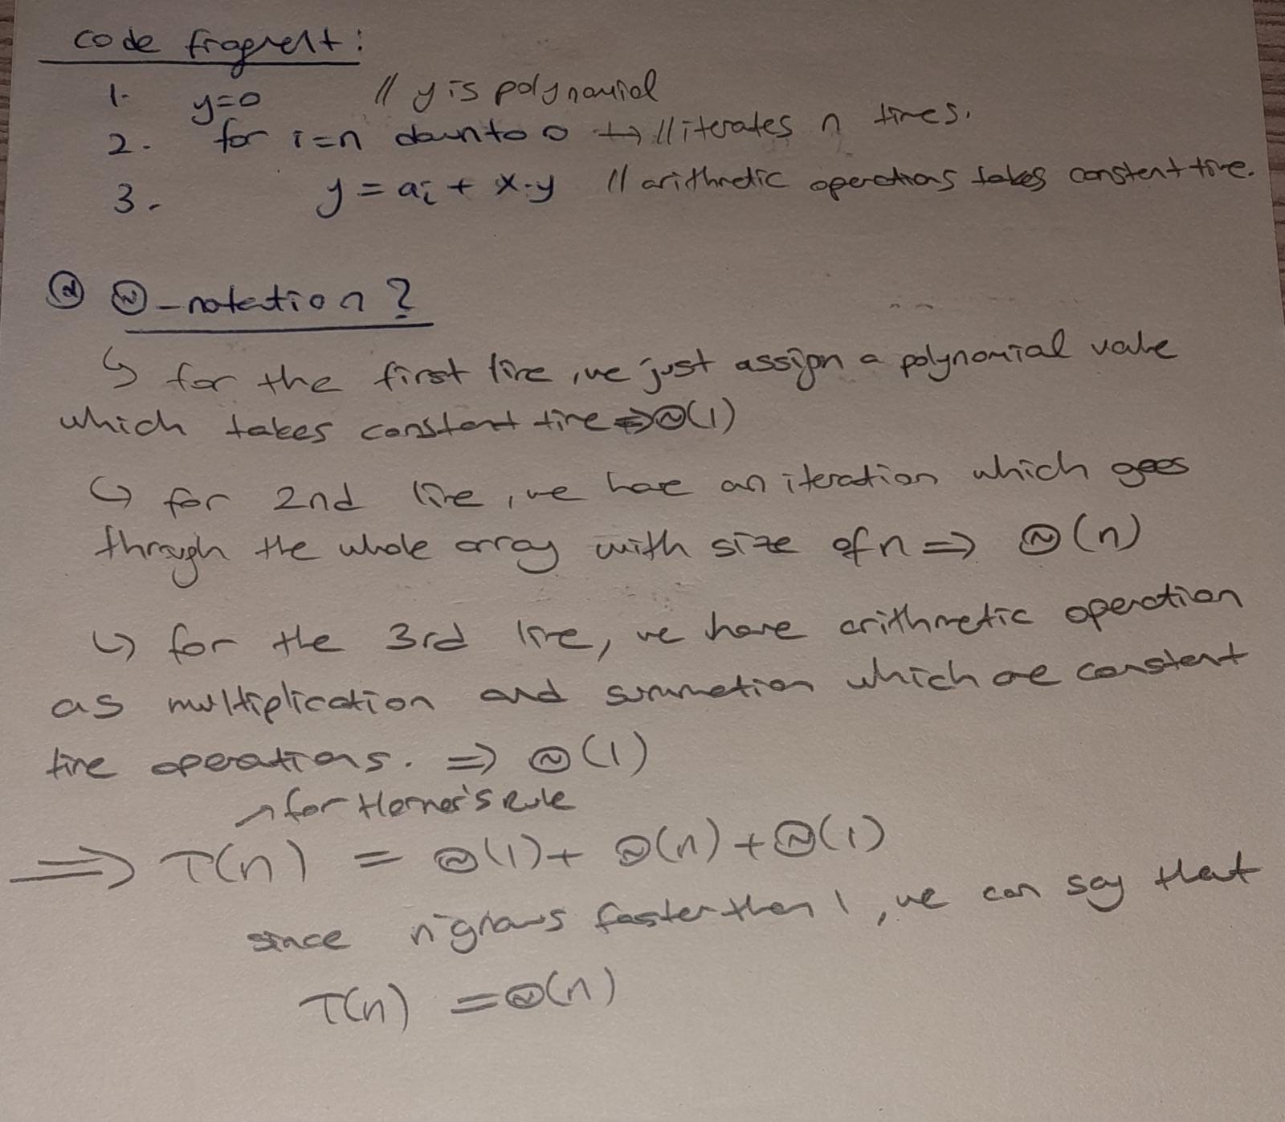

Q.3.b.

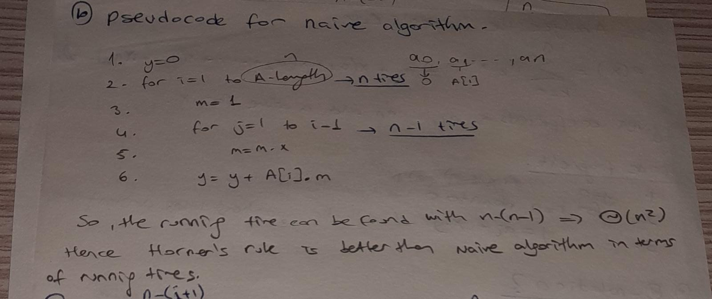

Q.3.c.

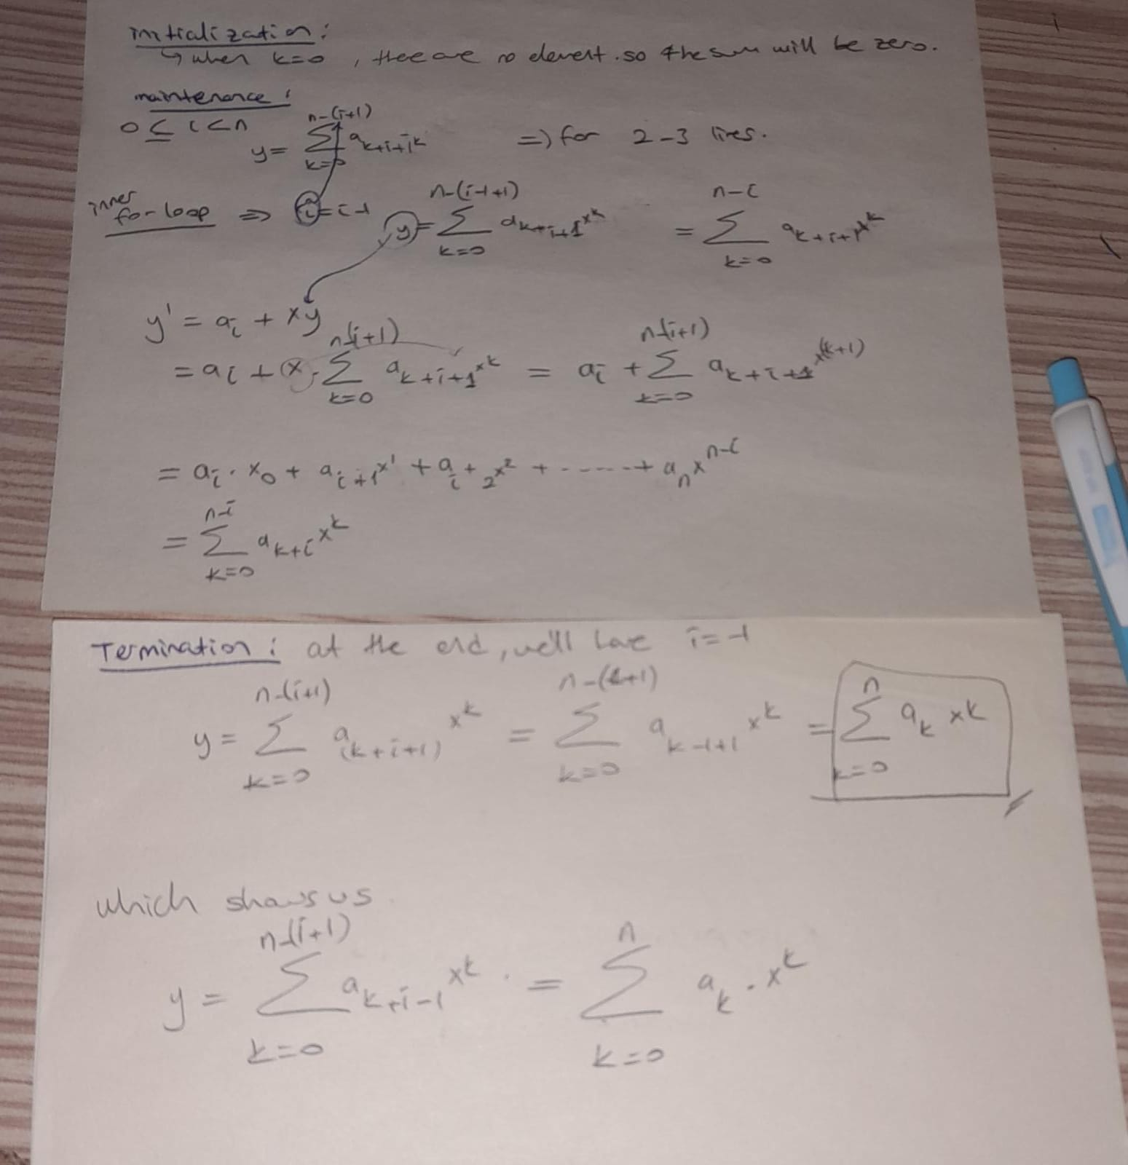

Q.3.d.

We can find a polynomial characterized by the cofficients a0 , a1 , … an with using Horner’s rule which shows us the algorithm holds for n values which is greater or equal to 0.